User's Manual

This is a 3D RPG game created on Unity, it called Happy Defence Friday. The idea comes from Black Friday, usually people get crowded and waiting in crazy long lines for black Friday sales. Basically, the game is to avoid crazy customers enter the store. The player is a knight who is hiring by the store, the health bar is hourly wage he gets. The enemies are customers which are men in blue suits.

There are two maps and two modes. In easy mode, enemies follow a single line to enter the store (on the left in the start menu). However, customers will come from random ways in hard mode.

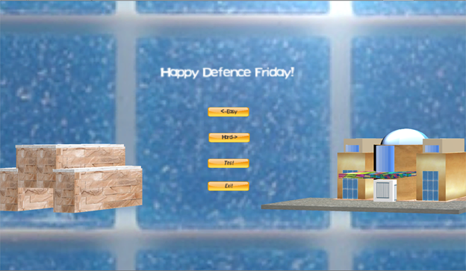

The health bar is the green one, and the energy bar is the blue one. Since the health bar is hourly wage he gets, when player destroying enemies he gains more money, the health bar grows. Otherwise, when enemies enter the building, he lose amount of money and the green bar decreases.

Below is the map for the easy mode, and the store is set to closed and the player need to avoid any enemy enter the building.

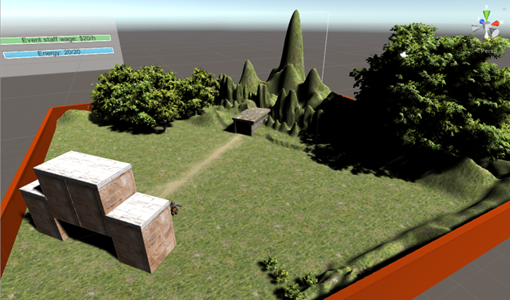

The easy mode helps you to practice how to control the player. Right click the mouse to move the player. As we set the main camera follows the player, so you will see the player is always at the center of your screen.

When the player meet enemies, press “A” to do normal attack, sway his sword to flight.

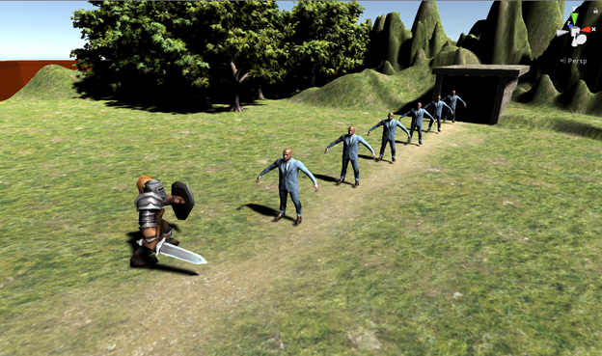

When the player levels up, he can use skills. Press “Q” to throw fire balls.

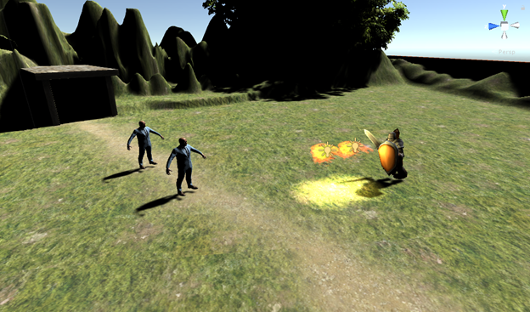

The skill costs energy which is the blue bar. If the energy is empty, you cannot use fireball anymore until you level up. Then energy and health will fill up after level up and you can use ability again.

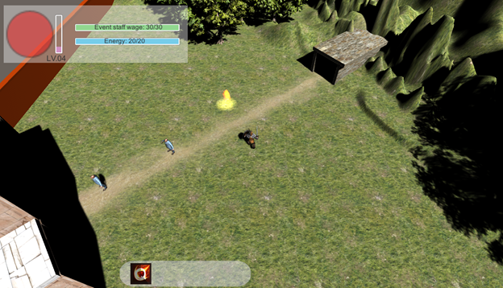

Then experience bar is the purple one. Kill enemies can get experience so that the player can level up. However, the higher the player's level, the more experience required to reach the next level.

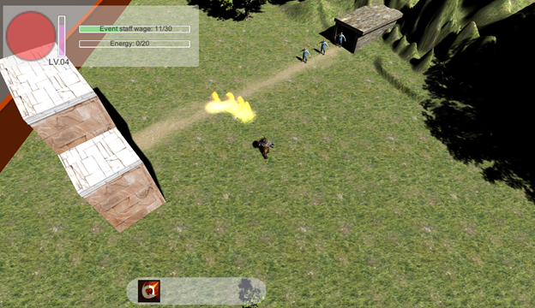

Below is the map of hard mode. As we can see, there are customers in line, so the player needs to avoid inpatient crazy who is trying to rush to the mall.

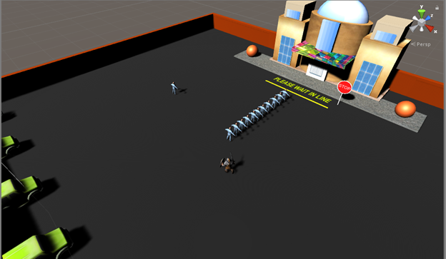

When enemies enter the mall, the green bar decreaes.

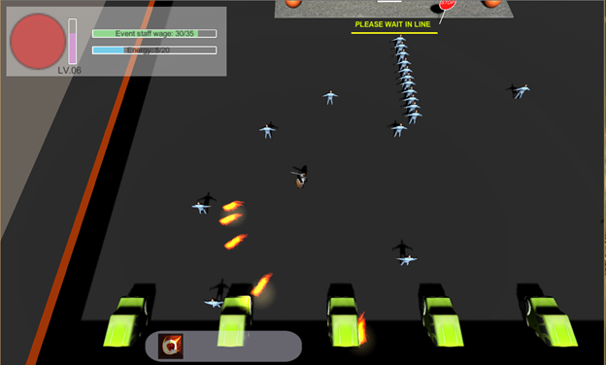

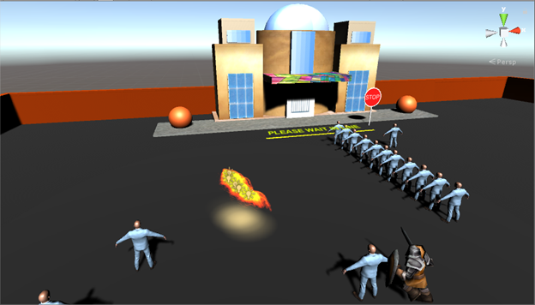

This is the screenshot of the test.

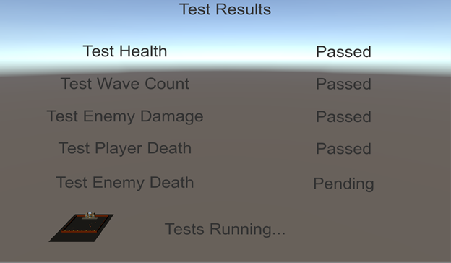

When you lose the game(the staff wage reduce to zero), then game over and you are fired. You can tip restart button to go back to the main menu.

